Material Suplementario
COMPARACIÓN DE LA MORTALIDAD EN PACIENTES EN QUIMIOTERAPIA O INMUNOTERAPIA DURANTE Y ANTES DE LA PANDEMIA DE COVID-19. ESTUDIO MULTICÉNTRICO DE COHORTES EMPAREJADAS

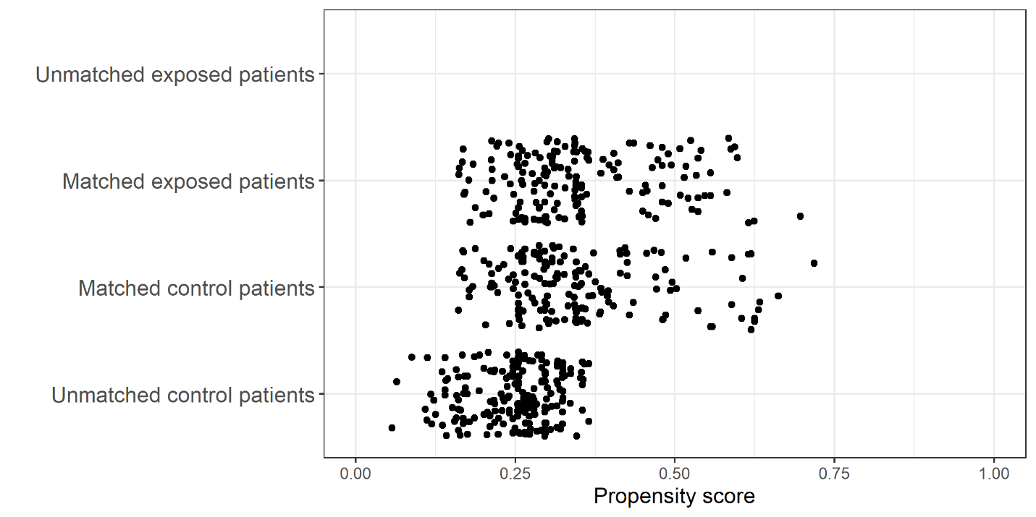
Figure 1. Distribution of propensity scores according to the exposure to pandemic.

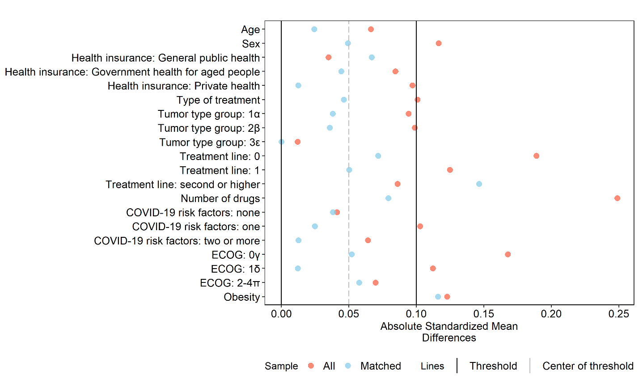 Figure 2. Absolute Standard Mean Difference for each variable.

Table 2. Comparison of cohorts before matching.
Variables | Pandemic (N=169) |  | Pre-Pandemic (N=377) |  | P-Value
 | n/N | % | n/N | %
Age
<=65 | 102/169 | 60.4% | 238/377 | 63.1% | 0.601
>65 | 67/169 | 39.6% | 139/377 | 36.9%
Sex
Male | 63/169 | 37.3% | 118/377 | 31.3% | 0.203
Female | 106/169 | 62.7% | 259/377 | 68.7%
Health insurance type
General Public Health | 23/167 | 13.8% | 51/376 | 13.6% | 0.580
Government Health for Aged | 34/167 | 20.4% | 63/376 | 16.8%
Private health | 110/167 | 65.9% | 262/376 | 69.7%
Treatment Type
Chemotherapy | 154/166 | 92.8% | 360/377 | 95.5% | 0.275
Immune therapy | 12/166 | 7.2% | 17/377 | 4.5%
Tumor type group
1 ª | 55/169 | 32.5% | 139/377 | 36.9% | 0.539
2,4,5 ^{b} | 77/169 | 45.6% | 154/377 | 40.8%
3,6 ^{c} | 37/169 | 21.9% | 84/377 | 22.3%
Treatment line
(Neo)adjuvant | 76/169 | 45.0% | 135/376 | 35.9% | 0.129
First line | 57/169 | 33.7% | 151/376 | 40.2%
Second or higher | 36/169 | 21.3% | 90/376 | 23.9%
Number of drugs in the treatment scheme
One or two | 159/168 | 94.6% | 336/377 | 89.1% | 0.057
Three or more | 9/168 | 5.4% | 41/377 | 10.9%
COVID-19 risk factors
None | 55/169 | 32.5% | 114/377 | 30.2% | 0.565
1^{d} | 60/169 | 35.5% | 152/377 | 40.3%
2-6^{d} | 54/169 | 32% | 111/377 | 29.4%
ECOG
ECOG 0 | 50/168 | 29.8% | 141/377 | 37.4% | 0.205
ECOG 1 | 100/168 | 59.5% | 204/377 | 54.1%
ECOG 2-4 | 18/168 | 10.7% | 32/377 | 8.5%
Obesity
No | 127/161 | 78.9% | 250/342 | 73.1% | 0.198
Yes | 34/161 | 21.1% | 92/342 | 26.9%
ECOG: Eastern Cooperative Oncology Group.
ª Testicular, Prostate, Breast, Gastrointestinal Stromal Tumor
^{b} Anal, Penile, Cervical, Colorectal, Soft tissue and bone sarcomas, Melanoma, Endometrial Renal, Head and Neck, Bladder, Ovarian, vulvovaginal, non-melanoma skin cancer
^{c} Biliopancreatic, Hepatocarcinoma, Lung, Mesothelioma, Esophageal, Gastric, Central Nervous System cancer
^{d} Number of COVID-19 risk factors: smoking or former smoking, respiratory diseases, arterial hypertension, heart diseases, diabetes, immunodeficiencies/chronic use of corticosteroids, chronic kidney disease, chronic liver disease.

